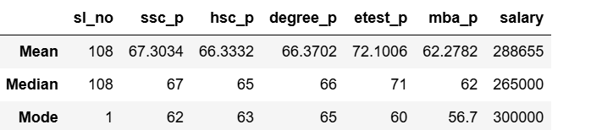

From this placement data we found ssc p are average 67.33%

hsc p are averages 66.37%

etest are average72.10%

degree p average 66.37%

mba p average 62.27%

average students are getting salary 288655

from median results are also average percentage and salary 265000

so there is an outlier is present in median

from mode results repeation in

62% ssc p

63%hsc p

65%degree p

60%etest p

56.7%mba p

From the placement data students are average students and getting etest only 72.10% good results

Average students are getting salary 288655